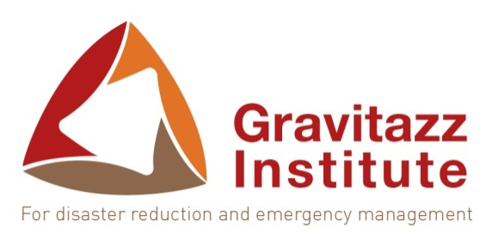 | Gravitazz Institute for Disaster Reduction and Emergency Management  Unit 35 / Constantia Square Office Park,  526, 16th Road, Midrand, South Africa  Telephone: +27 11 067 0321  Email: info@gravitazzcontinental.com  Website: http://www.gravitazzcontinental.com/

REGISTRATION FORM – SHORT COURSES
- Personal information
First Name
Last Name
Gender
Date of Birth
Nationality
Occupation (if applicable)
Organization (if applicable)
Languages Spoken
- Contact information
Mobile Number(s)
E-mail Address
Physical Address
Skype ID (if applicable)
- Course Registration
I would like to register for the following course(s): | Course title: Use of GIS Technology for Emergency Preparedness and Response: Meteorological Forecasts in Disaster Risk Reduction Planning  Date: 4-7 December 2017  Location: Abuja, Nigeria (Rockview Hotel Royale)
- Signature
I have read and accepted the terms and conditions outlined below and wish to confirm my registration for the course(s) listed in the above section.
Date:
Name:
Signature:

TERMS AND CONDITIONS – SHORT COURSES
- Training Costs
  - Training costs for the five-day courses are set at US$ 550 per participant, which includes:
- Facilitation costs
- Course materials and certificates
- Lunch and Refreshments
  - Payment will have to be made upfront, no later than two weeks (14 days) before the training’s starting date.
  - Payment will be made directly into Gravitazz Institute’s bank account (details provided below) and proof of payment transferred by email to info@gravitazzcontinental.com .
  - Gravitazz Institute’s Banking details are as follows:
Account Holder: GRAVITAZZ CONSULTING PTY LTD
Bank: FIRST NATIONAL BANK (FNB)
Account Number: 62467365609
Branch Name: GREENSTONE
Branch Code: 201510
* Swift Code (for international payments): FIRNZAJJ

- Cancellation
  - Gravitazz holds the right to cancel any training should the target number of participants (10 participants) not be met.
  - In the event of Gravitazz cancelling the training, the cost of the registration fee will be returned to the clients.
  - All bookings will be accepted as confirmed and organisations are welcome to make name changes one week prior to the workshop.
  - Any cancellation in full will carry a cancellation fee of 50% or at the discretion of Gravitazz but not less than 18%.
  - Gravitazz will not be liable in the event that the event is cancelled, postponed due to the fortuitous event, unforeseen occurrence, Act of God or any other event that might render this event impossible or impracticable. For the purpose of this clause, a fortuitous event shall include but not be limited to: war, death, fire, strike, extreme weather or other emergency.
  - Events, programme content and facilitators are subject to change without notice.

- Limitation of Liability
  - The client indemnifies and holds Gravitazz, its directors, employees and members harmless against any claim of whatever nature which may be made against any of them (including legal costs on an attorney and own client scale) resulting from or occasioned by the function, howsoever arising including but not limited to personal injury, death, loss of or damage to property brought onto or left on the property; but not limited to any claim for any loss or damages suffered by the client, brought onto or left on the property; but not limited to any claim for any loss or damages

Please note that the personal information that you provide in this form will remain confidential and that it shall only serve Gravitazz in sourcing statistics with regards to the profile of its prospective and actual students.

